Deployment Guide: Kalinger Ai Web Application
This guide outlines the steps to deploy Kalinger Ai web application built with ReactJS (frontend), Django REST Framework (backend), PostgreSQL (database), Apache2 (web server/proxy), and integrating Gemini 2.5 Pro and Google Cloud Storage (GCS) for AI processes.
Target Environment: Linux Server - Ubuntu Server 24.04 LTS
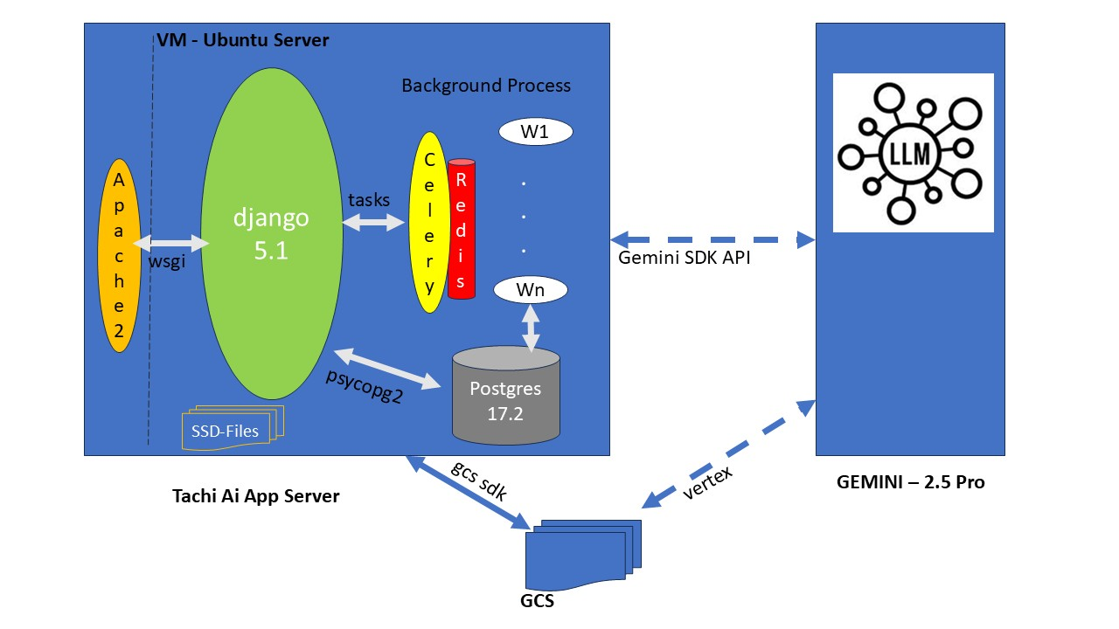

Prerequisites:
- Server OS: Linux Server - Ubuntu Server 24.04 LTS
- NOTE: If install on Windows server, go to windows power shell and rull command: wsl --install
- A dedicated Linux server (VM or physical) with 32GB, 650GB SSD/Storage.
- Root or sudo privileges on the server.
- Domain name (or internal DNS entry) configured to point to your server's IP address.
- Basic understanding of Linux command line, networking, and security.
- Google Cloud Project with billing enabled for Gemini 2.5 Pro and GCS.
- Service Account with necessary permissions for Gemini and GCS.
- Version Control System (e.g., Git) for your codebases.

NOTE: Reference: Install Ubuntu 24.04 with GUI in Windows 11 using WSL2
GitHub - SCSBalaji/Install-Ubuntu-24.04-using-WSL2: Step-By-Step Process to Install Ubuntu in Windows 11 using WSL2

1. Server Setup & Initial Configuration
- VM server Update:
Use the command to Update all the components to latest version:
sudo apt update && sudo apt upgrade -y

- Create a Deployment User (Recommended for Security):
sudo adduser deployuser
sudo usermod -aG sudo deployuser
# Switch to this user for further steps (or use sudo)
su - deployuser
sudo addgroup kalinger_ai_group
sudo usermod -a -G kalinger_ai_group deployuser
sudo apt install acl
sudo setfacl -m u:deployuser:rwx /var/www
- Configure Firewall (UFW):
Allow SSH, HTTP, and HTTPS.
sudo ufw allow OpenSSH
sudo ufw allow 80
sudo ufw allow 443
sudo ufw enable
sudo ufw status

2. Database Setup: PostgreSQL
- Install PostgreSQL 17:
OLD Version , if installed, follow steps to remove it:
If installed, stopped the services:
sudo systemctl stop postgresql
dpkg -l | grep postgres
sudo apt-get --purge remove postgresql postgresql-16 postgresql-client-16 postgresql-client-common postgresql-common postgresql-contrib
dpkg -l | grep postgres
sudo apt-get --purge remove <package_name_1> <package_name_2>
sudo apt-get --purge remove postgresql*
sudo rm -rf /var/lib/postgresql/
sudo rm -rf /var/log/postgresql/
sudo rm -rf /etc/postgresql/
sudo deluser postgres
Postscript ver 17 installation (if default available)
sudo apt install curl ca-certificates
sudo install -d /usr/share/postgresql-common/pgdg
sudo curl -o /usr/share/postgresql-common/pgdg/apt.postgresql.org.asc --fail https://www.postgresql.org/media/keys/ACCC4CF8.asc
sudo sh -c 'echo "deb [arch=amd64 signed-by=/usr/share/postgresql-common/pgdg/apt.postgresql.org.asc] https://apt.postgresql.org/pub/repos/apt $(lsb_release -cs)-pgdg main" > /etc/apt/sources.list.d/pgdg.list'
sudo apt update
(OR)
Step 1: Add the PostgreSQL APT Repository
First, update your local package index and install the necessary packages for managing repositories.
sudo apt update
sudo apt install curl ca-certificates gnupg postgresql-common -y
Next, use the automated script from PostgreSQL to add their repository to your system's package sources:
sudo /usr/share/postgresql-common/pgdg/apt.postgresql.org.sh
Alternatively,
you can manually add the repository and import the GPG key:
# Add the repository configuration file
sudo sh -c 'echo "deb http://apt.postgresql.org/pub/repos/apt $(lsb_release -cs)-pgdg main" > /etc/apt/sources.list.d/pgdg.list'
# Import the repository signing key
curl -fsSL https://www.postgresql.org/media/keys/ACCC4CF8.asc | sudo gpg --dearmor -o /etc/apt/trusted.gpg.d/postgresql.gpg
Finally, update the package list again to include the packages from the new repository:
sudo apt update
Step 2: Install PostgreSQL 17
Now you can install the specific postgresql-17 package:
sudo apt install postgresql-17 postgresql-contrib -y
The postgresql-contrib package adds extra utilities and functionality.
Step 3: Verify the Installation
The PostgreSQL service should start automatically after installation. You can verify the service status and the installed version using these commands:
Check service status:
sudo systemctl status postgresql
The output should show active (running).
Check PostgreSQL version:
psql --version
The output should display psql (PostgreSQL) 17.x
Access the psql shell as the postgres user:
sudo -u postgres psql
Set a password for the postgres user (recommended for security):
Once inside the psql prompt (postgres=#), run the following command, replacing 'your_secure_password' with a strong password:
ALTER USER postgres WITH PASSWORD 'kalinger@2026';
Exit the psql shell by typing \q and pressing Enter.

(OR)
sudo apt install postgresql postgresql-contrib –y

- Secure PostgreSQL (Optional):
Edit pg_hba.conf and postgresql.conf if needed for network access or specific security settings. For internal apps, peer --> trust authentication for local connections is common.
sudo nano /etc/postgresql/17/main/pg_hba.conf ---> (peer --> trust)
sudo nano /etc/postgresql/17/main/postgresql.conf -----> (peer --> md5 password encryption )
sudo systemctl restart postgresql

- Create Database and User:
sudo -i -u postgres
createuser --interactive --pwprompt kalinger_user
createdb --owner=kalinger_user kalinger_ai_alpha
(OR)
CREATE USER attendance_admin WITH ENCRYPTED PASSWORD 'Attenance@2026';
ALTER USER attendance_admin CREATEDB;
CREATE DATABASE attendance_db OWNER attendance_admin;
GRANT ALL PRIVILEGES ON DATABASE attendance_db TO attendance_admin;
//CREATE DATABASE kalinger_dev OWNER postgres ;

Install PGVector
Step 1: install pgvector in components
sudo apt update
sudo apt install postgresql-17-pgvector
sudo service postgresql restart

Step 2: Enable pgvector in PostgreSQL
After installing the binary, you must enable the extension for each database you plan to use.
- Switch to the postgres user:
bash
sudo -i -u postgres
- Connect to your database (replace mydb with your db name):
bash
psql -d attendance_db
- Run the following command:
sql
CREATE EXTENSION IF NOT EXISTS vector;

Step 3: Verify Installation
Verify that the extension is correctly installed by listing the extensions:
sql
\dx
You should see vector listed in the output.
CREATE EXTENSION pg_trgm;
Note: pip install pgvector in your venv

3. Backend (Django REST Framework) Deployment
3.1 Install Dependencies
- Install Python and Virtualenv:
sudo apt install python3 python3-pip python3-venv -y
sudo apt install python-is-python3
sudo apt install ffmpeg -y

- Create Project Directory and Access:
sudo mkdir /var/www
sudo mkdir /var/www/kalinger_dev
sudo chgrp -R kalinger_ai_group /var/www
sudo chmod -R g+rwX /var/www
- Clone Backend Code:
Note : Connect to my.vultr with sragu2008@gmail.com
Download and install FileZilla_3.69.3_win64-setup on local laptop
Connect to VULTR server with the info:
IP: 139.84.218.175enab
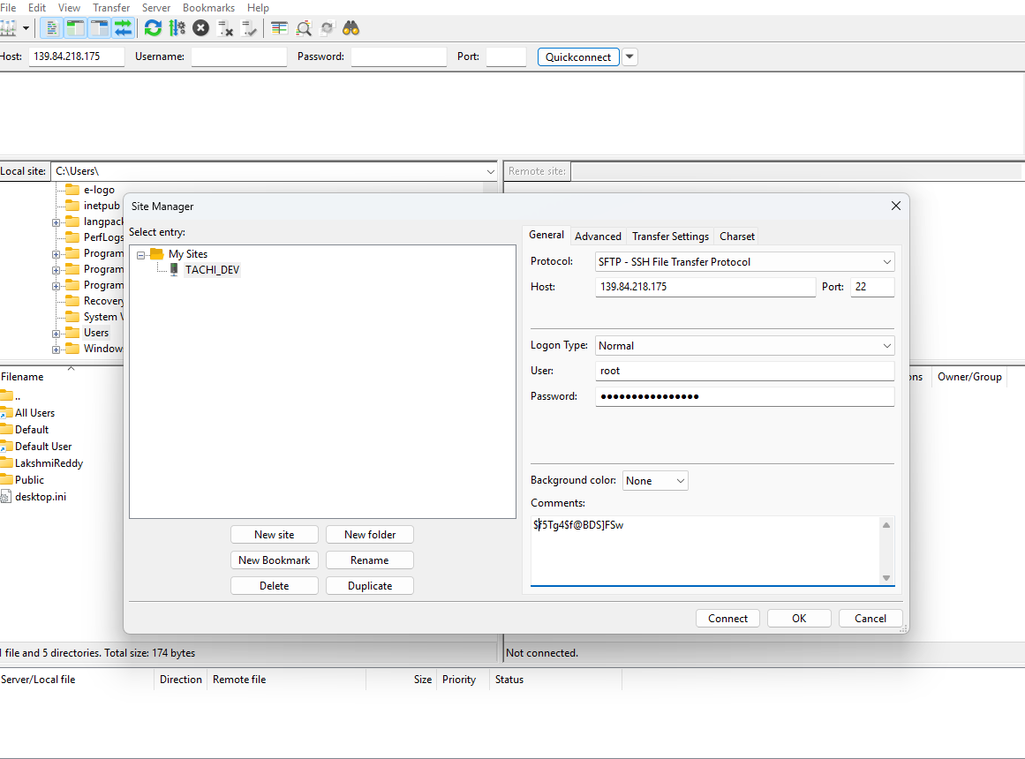
git clone https://github.com/itcus-ai/aiuto_recruiter (latest branch)

- Create and Activate Virtual Environment:
sudo apt update
sudo apt install python-is-python3
apt install python3.12-venv
sudo python -m venv venv
sudo source venv/bin/activate

- Install Python Dependencies:
pip install -r requirements.txt
(Ensure requirements.txt includes Django, djangorestframework, psycopg2-binary, , google-genai, etc.)
django-admin startproject kalinger_dev .

PlayWright
Skip Sudo password for www-data
sudo visudo
www-data ALL=(ALL) NOPASSWD: ALL
sudo -u www-data -H /var/www/venv/bin/python -m playwright install --with-deps chromium-headless-shell

3.2 Configure Django
- Collect Static Files:
python manage.py collectstatic --noinput

- Apply Migrations:
python manage.py migrate

- Create Superuser (Optional, for admin access):
python manage.py createsuperuser
kalinger-admin and admin@123
- Configure Environment Variables:
Create an .env file or set environment variables for sensitive data.
# Example .env file content
SECRET_KEY='your_django_secret_key'
DEBUG=False
ALLOWED_HOSTS='your_domain.com,your_server_ip'
DATABASE_NAME='your_app_db'
DATABASE_USER='django_user'
DATABASE_PASSWORD='your_db_password'
DATABASE_HOST='localhost'
DATABASE_PORT='5432'
GCS_BUCKET_NAME='your-gcs-bucket-name'
GOOGLE_APPLICATION_CREDENTIALS='/path/to/your/service_account_key.json' # For Gemini & GCS
# Gemini specific config
GEMINI_API_KEY='your_gemini_api_key' # If not using service account directly via client library
sudo systemctl restart apache2
Ensure GOOGLE_APPLICATION_CREDENTIALS points to a securely stored JSON key file for your Google Service Account. This file needs to be on the server.

4. Frontend (ReactJS) Deployment
5. Web Server Setup: Apache2 (Reverse Proxy & Static Files)
Apache2 will serve your React static files and act as a reverse proxy for your Django backend (via Gunicorn).
- Install Apache2 and Components:
sudo apt install apache2 -y
sudo a2enmod proxy proxy_http proxy_html proxy_balancer rewrite ssl headers
sudo apt install libapache2-mod-wsgi-py3
sudo a2enmod wsgi
sudo service apache2 restart
- Configure Apache Virtual Host:
Need to create three url for kalinger ai application, 1. UI App, 2.REST API for App and Whisper API.
  - Virtual Host for UI
Create /etc/apache2/sites-available/kalinger_ai_app.conf:
<VirtualHost *:80>
ServerName sriramlakshmiedainfront.in
DocumentRoot /var/www/kalinger_ai_alpha/aiedit_ui/
ServerAdmin raghu.s@edainfront.in
<Directory /var/www/kalinger_ai_alpha/aiedit_ui>
Options +FollowSymLinks
AllowOverride All
Require all granted
</Directory>
ErrorLog ${APACHE_LOG_DIR}/error.log
CustomLog ${APACHE_LOG_DIR}/access.log combined

RewriteEngine on
RewriteCond %{SERVER_NAME} =kalinger-ai-dev1.edainfront.in
RewriteRule ^ https://%{SERVER_NAME}%{REQUEST_URI} [END,NE,R=permanent]
</VirtualHost>

sudo a2ensite kalinger_devapi.conf

<VirtualHost *:443>
# SSL Configuration (assuming certbot for Let's Encrypt)
Refer the SSL section
  - Virtual Host for REST API
REST API uses Django Rest Framework and WSGI Module for communication with DJango. Here is the configuration file for API.
<VirtualHost *:80>
ServerName kalinger-ai-apix.edainfront.in
ServerAdmin raghu.s@edainfront.in
ServerAlias kalinger-ai-apix.edainfront.in
DocumentRoot /var/www/kalinger_ai_alpha
Alias /static /var/www/kalinger_ai_alpha/static
<Directory /var/www/kalinger_ai_alpha/static>
Require all granted
</Directory>

<Directory /var/www/kalinger_ai_alpha/aiedit_services>
<Files wsgi.py>
Require all granted
</Files>
</Directory>
WSGIDaemonProcess kalinger-ai-devapix.edainfront.in python-home=/var/www/kalinger_ai_alpha/venv python-path=/var/www/kalinger_ai_alpha
WSGIProcessGroup kalinger-ai-apix.edainfront.in
WSGIScriptAlias / /var/www/kalinger_ai_alpha/aiedit_services/wsgi.py
WSGIPassAuthorization On

ErrorLog ${APACHE_LOG_DIR}/error.log
CustomLog ${APACHE_LOG_DIR}/access.log combined

RewriteEngine on
RewriteCond %{SERVER_NAME} =kalinger-ai-dev1apix.edainfront.in
RewriteRule ^ https://%{SERVER_NAME}%{REQUEST_URI} [END,NE,R=permanent]
</VirtualHost>

WSGIDaemonProcess your_app_name python-home=/path/to/your/virtualenv processes=2 threads=15 display-name=%{GROUP} request-timeout=300
  - Whispher REST API
Whisper hosted as separate application uses application venv and separate Django project. Here is the virtual host configuration for setup the appication. Refer Whisper setup for installation and configuration of Whisper Model.
Listen 8001

<VirtualHost *:8001>
ServerName kalinger-alpha-whisper-apix.edainfront.in
ServerAdmin sraguram@yahoo.com
ServerAlias kalinger-alpha-whisper-apix.edainfront.in
DocumentRoot /var/www/whisper_services
Alias /static /var/www/whisper_services/static
<Directory /var/www/whisper_services/static>
Require all granted
</Directory>

WSGIDaemonProcess kalinger-alpha-whisper-apix.edainfront.in processes=2 threads=15 display-name=%{GROUP} python-home=/var/www/kalinger_ai_alpha/venv python-path=/var/www/whisper_services request-timeout=600
WSGIProcessGroup kalinger-alpha-whisper-apix.edainfront.in
WSGIScriptAlias / /var/www/whisper_services/whisper_services/wsgi.py
WSGIPassAuthorization On
<Directory /var/www/whisper_services/whisper_services>
<Files wsgi.py>
Require all granted
</Files>
</Directory>
ErrorLog ${APACHE_LOG_DIR}/whisper_error.log
CustomLog ${APACHE_LOG_DIR}/whisper_access.log combined

</VirtualHost>

sudo a2ensite kalinger_devapp.conf

6. SSL/TLS Configuration (Let's Encrypt with Certbot)
- Install Certbot:
sudo apt install certbot python3-certbot-apache -y
- Obtain and Install SSL Certificate:
sudo certbot --apache -d dev.kalinger.ai
Follow the prompts. Certbot will automatically configure Apache and set up renewal.
7. ReactJS Deployment
Using npm for build the code and copy in the apache mapped folder, here is the steps to deploy reactjs components;
- Create Frontend Directory:
mkdir -p /var/www/kalinger_ai-alphaa/aiedit_ui/
cd /var/www/kalinger_ai-alphaa/aiedit_ui/
Create conf file for the UI and API mapping to the sub domain and folder
certbot -a webroot -i apache -w /var/www/kalinger-ai-alpha/aiedit_ui -d sriramlakshmiedainfront.in

- Build Frontend Code:
git clone https://github.com/itcus-ai/adobe_ui
npm install
Install all dependency libraries
Configure API Endpoint
Before building, ensure your React app's API calls point to your deployed Django backend (e.g., https://your_domain.com/api/). This is typically done in a .env file within the React project or directly in source code for internal apps.
npm run build - This will create a content and code containing optimized static files.

Copy the generated folder to /var/www/kalinger_ai-alphaa/aiedit_ui/
Change the API url in Config.js
REACT_APP_API_URL=https://your_domain.com/api
Link Data in API folder to UI:
ln -s /var/www/kalinger_ai_alpha/data /var/www/kalinger_ai_alpha/aiedit_ui/data

7. Google Cloud Services (Gemini 2.5 Pro & GCS)
This section assumes you've handled the service account key file on the server.
- Service Account Key:
Download your Google Cloud Service Account JSON key file from the GCP console (IAM & Admin -> Service Accounts -> Create/Manage Key -> Create New Key -> JSON).
Securely upload this file to your server. For example, place it in a restricted directory like /var/www/your_app/backend/config/ and ensure permissions are tight (e.g., sudo chown deployuser:www-data /var/www/your_app/backend/config/your_service_account_key.json and sudo chmod 400 /var/www/your_app/backend/config/your_service_account_key.json).
Update your GOOGLE_APPLICATION_CREDENTIALS environment variable in the Gunicorn service file or .env to point to this file.
- Gemini 2.5 Pro:
Ensure the service account has the Vertex AI User role to access Gemini APIs.
The Django backend code will use the google-generativeai and google-cloud-storage Python libraries. These libraries will automatically pick up the GOOGLE_APPLICATION_CREDENTIALS environment variable.
- GCS Bucket:
Create GCS bucket kalinger Ai Google Cloud Project. The service account used must have Storage Object Admin or Storage Object Creator/Viewer roles as needed.
Bucket Name : dev_kalinger01
Location type : Region
Location: us-east1
Storage class : Standard
- Install GS UTIL/SDK and configure
To install gsutil on Ubuntu, the recommended method is to install the entire Google Cloud SDK, which includes gsutil as a component.
1. Import the Google Cloud public key:
For newer distributions (Ubuntu 18.04+):
curl https://packages.cloud.google.com/ apt/doc/apt-key.gpg | sudo gpg --dearmor -o /usr/share/keyrings/cloud.google.gpg
For older distributions (where apt-key --keyring is not supported):
curl https://packages.cloud.google.com/apt/doc/apt-key.gpg | sudo apt-key add -
2. Add the Cloud SDK distribution URI to your sources list:
echo "deb [signed-by=/usr/share/keyrings/cloud.google.gpg] https://packages.cloud.google.com/apt cloud-sdk main" | sudo tee -a /etc/apt/sources.list.d/google-cloud-sdk.list
3. Update and install the Google Cloud SDK:
sudo apt-get update && sudo apt-get install google-cloud-sdk
4. Initialize the Cloud SDK:
gcloud init
This command will guide you through the initial setup, including logging into your Google Cloud account and configuring your default project.
After completing these steps, gsutil will be installed and accessible from your terminal. You can verify the installation by running gsutil version.
gsutil cors set cors.json gs://dev_kalinger01
- Celery Installation and Configuration
This section explains how to install, configure, and deploy Celery with Redis

1. Prerequisites

System Requirements
- Linux server (Ubuntu 20.04+ recommended)
- Python 3.9+
- pip / virtualenv
- sudo or root access

Application Requirements
- Django application
- Network access between Django, Celery workers, and Redis

2. Redis Installation (Message Broker & Result Backend)

2.1 Install Redis
sudo apt update
sudo apt install redis-server -y
2.2 Restart Redis:
sudo systemctl restart redis

2.3 Verify Redis
redis-cli ping
Expected output:PONG

3. Celery Installation

3.1 Python Environment Setup
python3 -m venv venv
source venv/bin/activate

3.2 Install Dependencies
pip install celery redis django-celery-beat

4. Django Configuration

4.1 Enable Apps
INSTALLED_APPS = [
'django_celery_beat'
]

4.2 Celery Configuration
CELERY_BROKER_URL = 'redis://[redis_host]:6379/0'
CELERY_RESULT_BACKEND = 'redis://[redis_host]:6379/1'

4.3 Initialize Celery App
Create celery.py:
import os
from celery import Celery
os.environ.setdefault('DJANGO_SETTINGS_MODULE', 'project.settings')
app = Celery('project')
app.config_from_object('django.conf:settings', namespace='CELERY')
app.autodiscover_tasks()
Update __init__.py:
from .celery import app as celery_app
__all__ = ('celery_app',)

5. Database Migrations
python manage.py makemigrations django_celery_beat
python manage.py migrate django_celery_beat

6. Validation Checklist
  - Redis is running and secured
  - Celery workers respond to inspect ping
  - Periodic tasks visible in Django admin
  - Tasks execute successfully

7. Common Deployment Pitfalls
  - Redis exposed publicly
  - Missing result backend migrations
  - Workers running with insufficient memory

- Whisper Installation and API
This section explains how to install, configure, and deploy WHISPER API
- Prerequisites
OS & System Dependencies
sudo apt update
sudo apt install -y \
ffmpeg \
git \

- Create Virtual Environment
python3 -m venv whisper_venv
source whisper_venv/bin/activate

- Install whisper
pip install torch --index-url https://download.pytorch.org/whl/cpu
pip install openai-whisper
pip install whisperx

- Install additional packages
pip install numpy scipy tqdm soundfile

8. Final Checks and Maintenance
- Access Application: Open https://sriramlakshmiedainfront.in/ in your browser.
- Test Functionality:
  - User authentication.
  - Data retrieval/creation/update.
  - API endpoints.
  - AI features (Gemini integration).
  - File uploads/downloads (GCS integration).
  - Django admin panel (https://kalinger-ai-apix.edainfront.in/admin).
- Monitor Logs:
  - Apache: /var/log/apache2/access.log, /var/log/apache2/error.log, /var/log/apache2/
  - PostgreSQL: /var/log/postgresql/ (or check via journalctl)
  - Django: Configure internal logging to files or a centralized logging system.

